Summary of the last few sessions:

***Arrival on Solem Reyk***

The mists thickened as the party sailed north, their five ships moving slowly through the increasingly-icy waters. Fiora called from the crow’s nest:

“I see land!”

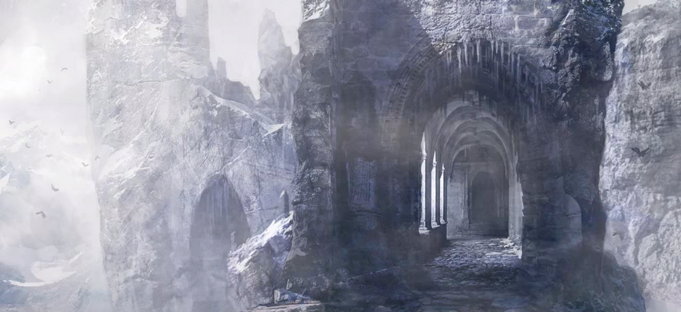

*Solem Reyk*

The ships closed in on the rocky island and made anchor—only to be greeted by a small group of five people. Raime climbed onto the rocky shore and carefully looked the people over—it was clear that they were expecting someone, but the party had not sent any word of their arrival to the island. One of the five stepped forward, his black leather trench coat moving in the mist. His voice was thick with a northern accent:

“Welcome to **Solem Reyk**! What brings you here? Are you inspectors to see our progress?”

Without hesitation, Ander spoke, “You bet we are.” (Deception upwards of 26)

The party was lead into the halls of the ancient fortress. The archways were carved with amazingly intricate pictures and words, and many of the hallways had open archways for walls, filling the entire place with fog. The leader introduced himself as **Cassian**, and brought the group to a large hall. The chamber was filled with a long table, set with food for six. “I apologize for our ill preparedness, we simply weren’t expecting any guests. We can fetch each of you a meal right away. Please, take a seat.”

As they sat, Cassian introduced the rest of his group: Two were mute twins, **Liam and Lian**, their tongues cut out for improper speech against their liege lord. One was an older woman, **Zan**, with white hair and dark copper skin, lightened with powder. She silently watched each of the adventurers, Raime most. The last, **Rovald**, was a stern man with receding blonde hair and a face covered in battle scars. Even at the table he wore armor and kept his broadsword at his side. Cassian spoke with each of them as he ate, “I can show you the progress with the tunnels in the morning—no way we’re going down while its dark.” He suddenly stopped— “Any of you happen to be magic users? Eh?” Moog jumped in, “No, none of us. I myself hate magic. With a passion. Fuck magic.”

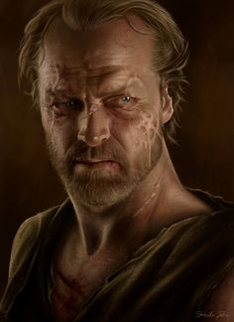

Cassian slowly went back to eating, “Damn magic is what’s wrong with this world. If I had it my way, mages would be locked up, or maybe we could send ‘em to the Endlands. Give ‘em to the savages there.” He spits at Zan. “She’d go first. Damn witch.”

Upon questioning, Cassian explains that they were expecting their boss to be arriving, but it seems like he is running late. Cassian showed them their chambers—cold stone rooms with nothing to furnish them. “Again, we apologize for the ill accommodations. Had we expected inspectors, we would have made up a few rooms! Liam! Lian! Fetch some straw!”

The next morning, Cassian and the others prepared the party to go down into the tunnels. “You may want to bring a weapon, if you’re trained. The shadows aren’t the most welcoming.”

*Rovald*

The company met at the main excavation site—a large stone dais surrounded by pillars under the open sky. The dais had been torn up, with stairs and platforms going down for about twenty feet. One stairway descended deeper into the stone. The stairs led to the tunnels—more catacombs than anything. The walls of the catacombs were covered with skulls—human, elf, orc, giant, animal, other. No race was an exception to the catacombs beneath Solem Reyk. The torches of the group cast ominous, dancing shadows on the skulls of the dead.

“These catacombs stretch for hundreds—maybe thousands—of miles beneath the straights. There are similar ones ‘neath the Jotungard fortresses, and we suspect that these run up north to Mazica, and west to the Endlands as well. We had scouts move west through the tunnels, and they traveled five weeks without reaching an end to ‘em.

“Our job—at least what we’ve been told—is to connect these tunnels ‘ere to the ones ‘neath the Jotungards. Don’t know what for, don’t care.” Cassian continued to talk as he shows the “inspectors” the most recent dig site. The tools were there, the progress seemed real, but Raime noticed that there was a good layer of dust over the area—it hadn’t been worked on in some time. The group was walking to the next main site when Rovald suddenly stopped in front of them, “Cassian. I need to speak to you up ahead. Everybody else, stay back.”

As the two were speaking away from the group, only their torch visible down the tunnel, Fiora had an idea—it seemed to be the tunnel that stopped Rovald, at least, she overheard him saying, “That tunnel wasn’t there before. Let’s keep them moving and check it out later.” Naturally, she wanted to fire a flaming arrow down the path to see where it led. She dipped her arrow in oil, used Moog’s magic to light it, and fired it off. The arrow hissed down the dark hallway before pattering down on a stone floor. The arrow was in a much larger room, but besides that nothing was visible. Immediately, Cassian yelled, “You idiot! That will draw them right to us!” The tunnels echoed the sound of him drawing his rapier, and Rovald unsheathing his broadsword.

The company all drew their weapons and brandished their torches as they moved in, back to back. The hallways began to hiss with whispers—almost as if the dead were warning of the darkness that enveloped them. Dark wisps began to seep from the walls and the darkness, almost like the tentacles of some vile being. The tentacles formed into forms, bodies with grotesque forms. The shadow beings bore unnatural numbers of limbs and blank heads, and they moved with frightening speed towards the huddled party. Four—five—six of them crawled down the hallway. Spells exploded from the party, swords and spears lunged outward. The shadows clung to their victims, ripping and tearing not only at the body, but at the soul. They sucked the strength from those they touched, and two reached Ander. His strength was sapped, and he collapsed to the floor, unable to even lift his head. The fight moved quickly, and before long, the shadows were destroyed. Immediately, the group retreated to the surface to heal from their injuries.

Ander’s injury was more serious than first thought—upon inspection, Rohme stated that it would take a few days for Ander to regain his strength. Fiora, Theon, and Moog worked to make Ander a wheelchair so he could move that night—for they weren’t wasting any time. The party planned to make for the mysterious tunnel once Cassian and his minions were asleep.

That night they made their move. Under cover of darkness and Fiora’s anti-tracking spell, they made for the excavation site. They descended into the tunnels with minimal light, and silently slunk to the place where the shadows attacked them. Kyrat heard a strange sound when they reached it—the closing of a door. The party cautiously continued down the mysterious hallway, and at its end they found an old wooden door. They opened it and went through to find a massive cavern. The cavern had a domed ceiling with large pillars holding it up. The floor was smooth marble, carved with beautiful inscriptions. The center of the floor was carved with a huge seal, the stone itself swirling and moving with a magical force. The far side of the massive cavern was dedicated to a huge door, covered with carvings and chronicles. As the party entered the chamber, the door was just closing. The walls were the same, and as they entered, Moog cast a spell to read the ancient languages on the wall.

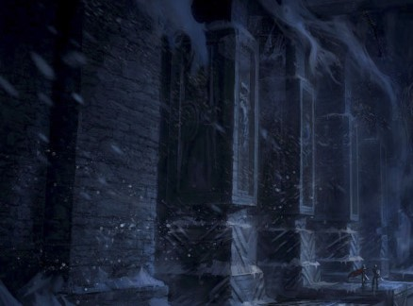

*Halls of Solem Reyk*

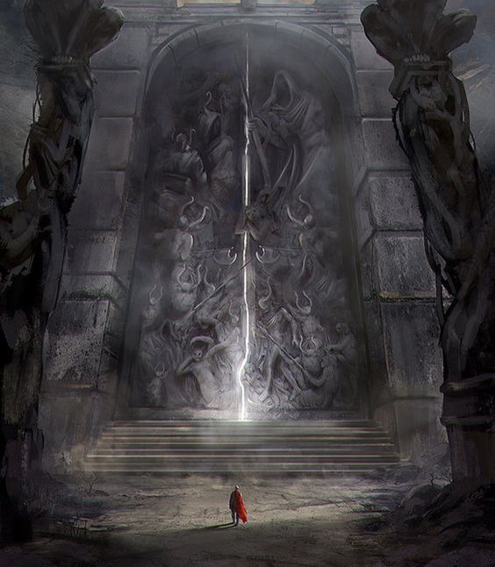z

*The shadows are corrupt, and they*

*Infect the dead and the living alike.*

*The orcs came down first, great swarms from the north.*

*The Riverlands were overrun by those*

*Who ran from the shadows.*

*Next came the giants, escaping to the North.*

*The giants were chased by the*

*Freeguard, and were hunted to elimination.*

*Third came the frightful dead,*

*The endless dead of the Land of War.*

*The Defiler sent his horrible plague across the land,*

*Corrupting all.*

*The seven bastards of Liliwyn found the five divine scrolls beneath*

*The ruins of Solem Reyk, and used*

*Them to end the Defiler’s scourge in Wysteria.*

*HE IS IMPRISONED.*

*We, the Mistwalkers of Solem Reyk,*

*Are the only ones to protect the land*

*From the Defiler. If any enter His Domain,*

*They will fall under his enchantments.*

*This must not happen.*

The solemn chronicle sat in the minds of the party as they looked through the dark chamber—in front of the door stood an ominous guardian, a giant suit of armor brandishing a great sword larger than itself.

Carefully, Fiora, Theon, and Raime snuck through the shadows towards the massive door. They readied their weapons as Ander rolled forward to talk to the guardian. He spoke to the suit of armor while simultaneously examining its every detail—the armor was empty, but spoke nicely. It answered Ander’s questions easily and without hesitation.

“What is this place?” the bard asked.

“You stand in front of Mirabel’s Door,” responded the smooth voice of the guardian.

“And who is Mirabel?” retorted Ander.

“Mirabel was the founding mother of the Mistwalkers, and the only of the seven bastards of Liliwyn Darieth to survive the journey into Amarth to imprison the Defiler.”

“May we enter this door?”

“Mirabel’s Door is open to Mistwalkers only.”

“Ah, but we are Mistwalkers!” lied Ander.

“I see. What is your name?”

“Ander Liadon. Is there a problem?”

“Yes,” rumbled the guardian, “The only surviving Mistwalkers are…Rohme Reynelis and Makil Seran. You may return and enter Mirabel’s Door when you are Mistwalkers.”

“I see…” Ander continued. He probed about the organization in general, and upon deciding that this suit of armor could be trusted—and could be a possible ally—he gave it this warning: “We believe that the people here—Cassian and the others—may be false, even malevolent—. “He was cut off by a northern voice from the back of the hall.

“Malevolent you say? Well, that’s not too nice.” Cassian walked in at the head of his followers, Liam, Lian, Rovald, and Zan, all in a ‘v’ shape behind him. “Now, we gave you our hospitality, and you lied to us. Inspectors, eh?” Cassian spit on the floor in front of him. “Now, our boss should be here very soon, and he won’t like visitors. We’ll give you one last chance. Leave now, and leave alive.”

“We refuse,” Ander spoke as he rolled closer to the guardian.

Cassian’s sigh was palpable. “Well…Then I guess you won’t leave this room alive. All hail the Defiler, am I right?”

Each side drew their weapons, and the fight commenced. Fiora, Theon, and Raime struck from the shadows, and Moog unleashed his magic from the seal on the floor. It soon became clear that Rovald and Zan were not fighting for Cassian, but for themselves. Rovald defended Zan as she cast defensive spells on him. As the fight got more serious, the façade of an old woman melted off her—an illusion. Underneath was a beautiful young Aamiran woman. She dropped her baggy robe to the floor, showing tight-fitting grey silks. Her arms were covered in tattoos—spells. Her body was her spell book, and she unleashed it upon those who came too close. Ander enchanted Cassian and forced him to attack Rovald, hoping to do some damage. As Cassian approached with his rapier, Rovald took one swift motion and cut him in half.

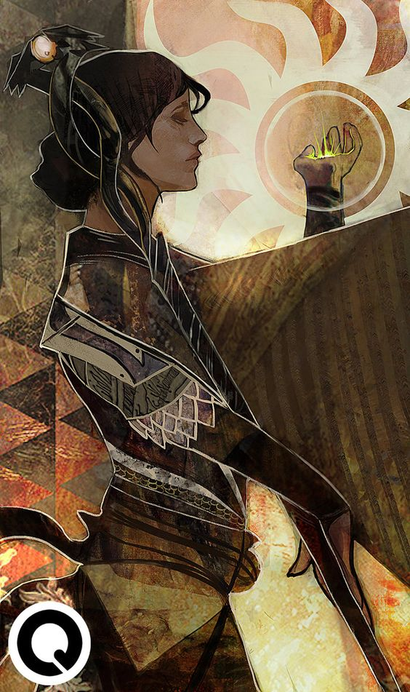

Liam and Lian lay dead, and Rovald and Zan were the only remaining. Rovald spoke up— “Look, we don’t want to fight. We were only hired by Cassian to serve as body guards down here in the tunnels. Can we agree on a truce?”

The two groups exchanged words and reasoning, and they decided to join forces. The fight had exhausted them all, and they lay down for a short rest…

The boats creaked and bobbed in the dark mists, and Kyrat was barely able to hold in his nausea. He had gotten a message from Ander earlier warning him to be wary, and he was. Nothing was out of the ordinary—until he saw the mists move. Over the water, the mists parted to reveal a slim black ship with high dark sails. The ship was headed towards the five anchored by Solem Reyk, but soon it turned parallel to the shore. Kyrat found Abel to tell him about the ship, but the warlock had already seen it and the single dark figure that stood at its bow.

The figure held two jagged short swords in his hands, one black and one white. The black one began humming and emanating a deep red glow. The figure held them out like wings as he dove into the water, quickly disappearing in the black waves. Kyrat and Abel were already in a row boat sailing over to the dark ship as he dove, and neither of the two adventurers knew what to think.

*Zan the Slaver*

As the dark figure reached the adventurer’s boats, the humming stopped—the water turned red, glowing, burning! An eruption of fire came from beneath the ships, like the water itself was turned to flame. Flames burst from the water, and the ships were engulfed. The screams of sailors ripped across the coastline. The fog around the ships began to burn and expand like a wave of fire through the air, but dissipated before it reached Kyrat and Abel.

The dragonborn and warlock could see the carnage clearly with the fog destroyed. Hot air swirled around them as their ships burned—they knew they had to get over there. Abel and Kyrat climbed aboard the black ship, and Abel steered it on a crash course with the flames. The swift ship cut through the waters and rammed one of the burning vessels. Immediately, Kyrat jumped into the flames to rescue the sailors. As Kyrat took on the burning ship, Abel confronted the dark figure now climbing aboard the ebony ship. Abel was quick on his feet, he dodged and fired his eldritch blasts—fists of black-green flame that seeped from his body. As Abel fought with the mysterious figure, he tried to understand everything about him—his robes were short and clean, wet; his short swords moved like water, so the assailant must be highly trained, in fact, Abel could barely evade his strikes. Abel wasn’t winning—he was being pushed back towards the ship’s railing, and he couldn’t hold off this guy on his own. He tried to buy time for Kyrat to return, but he slipped—and caught a sword across the chest. One slice, then Abel’s world was filled with pain—another stab, a second cut across the shoulder, another stab through the stomach. He fell into the water and into darkness.

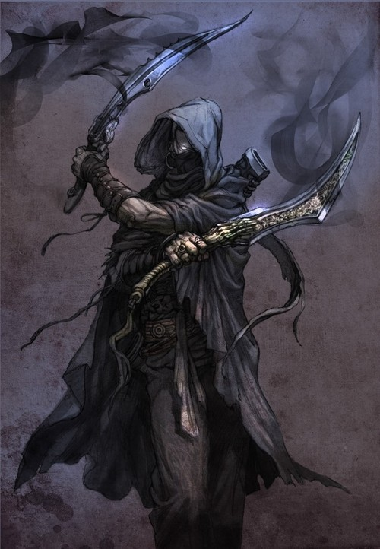Kyrat stepped back on the ebony ship, a burned sailor over each shoulder. He set the sailors down as he walked to the dark figure. He saw Abel fall into the water, and knew he didn’t have much time. He charged, using one hand to cast a spell, holding the dark figure in place and the other to work Flametongue like an extension of himself. He called down the holy powers of Habbakuk and felt a rush of righteous might. Kyrat stood in front of the paralyzed man and cut him—once, twice, three times. His sword ripped the figure’s body apart, spilling his blood all over the deck of the ebony ship.

In a swift motion, Kyrat sheathed Flametongue and dove into the opaque water. He swam down, and as he caught hold of Abel’s hand, he quickly channeled his holy energy to heal the warlock. As Kyrat resurfaced with Abel under his arm, his stomach sunk—a mass of dark tentacles hovered above the deck of the ship, pulsing with unholy power. The shadowy tentacles had erupted form the corpse of the dark assassin, and were now possessing his body. The black sword began to hum and turn red once more. The two adventurers swam for the shore.

-------------------------------------------

*The Dark Figure, the Hunter*

A popping explosion echoed through the tunnels—a bad sound no matter what. Raime, Fiora, Theon, Ander, Moog, Zan, and Rovald hopped into action. They grabbed their gear and headed for the surface—be it an earthquake or something wrong at the ships. They wended their way through the tunnels, Moog’s magical lights casting sickening glows on the millions of skulls. As they emerged from beneath the great stone dais, Kyrat and Abel staggered into the clearing, breathing heavily. Abel held his side, still bleeding lightly, and Kyrat had his sword at the ready. Without saying any words, he pointed over the bordering hall they had just came from. A great shadow was washing over the roof of the walk way, tentacles of darkness attached to a grotesque corpse. The party took their positions behind the columns encircling the area. Raime readied his spears and stood next to Rovald in the open. The gruff veteran spoke softly to the monk:

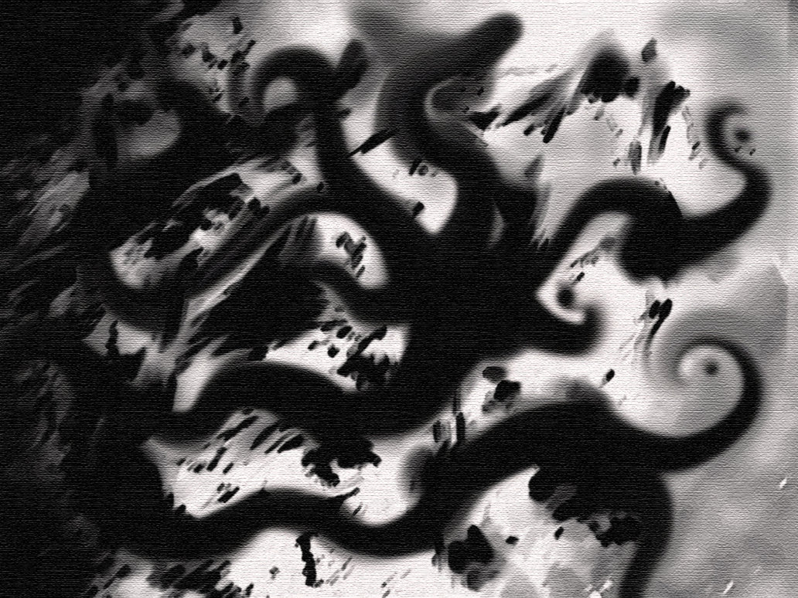“I see you too are not a man to back down from a challenge. Let’s die together, then, facing this monster in the fog.”

*Tentacles in the Fog*

The monster lunged at the two fighters at the center of the ring. Rovald’s skin hardened like stone as Zan cast a defensive spell on him, and Raime’s spears moved like lightning. Fiora and Theon’s arrows pierced the monster from the outskirts, and Moog’s spells blasted the creature. The beast pulled back from its initial attack and raised its arms, chanting. Suddenly, the fog began to condense and fall—rain. The black sword that burns water began to hum and glow once again. The tentacle monster rose into the sky, out of range of Rovald and Raime. Just as the creature pointed his humming sword towards the ground, ready to unleash an unyielding fire upon the party, Ander cast two quick spells—one to silence the area in an attempt to disrupt the sword, and the other to attack the mind of the monster. The creature was wracked with pain, and it became vulnerable. In the silence around the creature, Raime slid through over the wet stone floor, the rain dropping silently around him. It was almost as if time slowed in that moment as Raime wedged his silver spear into the ground beneath the monster and threw his Viper upwards, piercing the monster from below. The golden viper crawled through the shadow and burst from its mouth into the sky. The monster’s shadowy body fell, and was pierced by Raime’s silver spear—but the humming sword touched the ground, and its power was unleashed. The whole dais was engulfed with flames as the water burned—not everybody had to escape. The scene was chaos—people fell to the fires, unable to escape while others jumped to their aid. Zan cast spells to move the water and protect areas as Kyrat trudged through the burning water.

Just as the fires worsened, a great magical wave washed over the area, and the burning water lifted into the air, creating a dome of fire covering the area. The warmth was not painful, but soothing. Rohme Reynelis emerged from the tunnels, returned from beyond Mirabel’s Door. She took the fire and sent it out into the sky, and the area was enveloped in a silent calm. Raime staggered to Rohme and fell to his knees—he threw down his holy symbols, he threw down his gods and proclaimed his goal—to become a Mistwalker, just like Rohme. Others did the same—Ander, Fiora.

*“You want to become a Mistwalker? Then we shall go to Mazica, and you shall train.”*